How to Create and Import a Robot Project in Eclipse (2015)

1. Open Eclipse
2. Open Robot Builder

This can be done by

1. Selecting the Robot Builder Icon

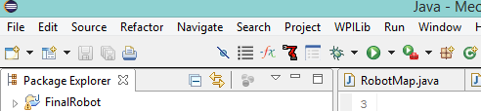

1. Or by selecting WPIlib->Run Robot Builder
2. Next fill out robot name and team number. It should appear in a small window following the selection of the Robot Builder icon.

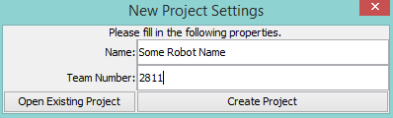

1. The Robot builder app should open for you. Before you begin building, change your team number from 0000 to 2811. Also, make sure that you save to your workspace.

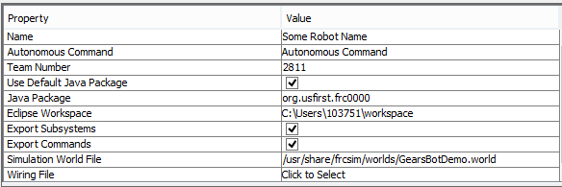

1. Drag and drop whatever commands and subsystems you need. Remember that you need to create a drive or chassis subsystem if you want your robot to drive.
2. When you are ready to export your file, save your robot into your workspace. You will have to type in the name of your robot to save it. You may not see the folder for the robot at this time.

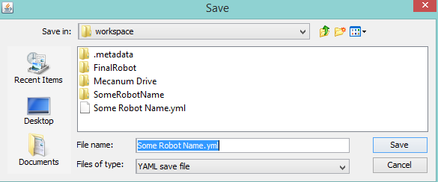

1. Next, select verify to ensure that your robot is valid. Then select java as your programming language.

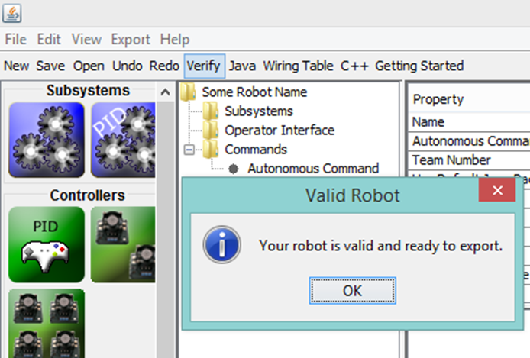

1. You must then select export ->Java to actually export your file.

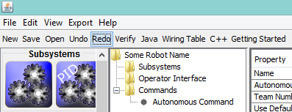

1. Open Eclipse. Select File->Import->General->Existing Projects into Workspace

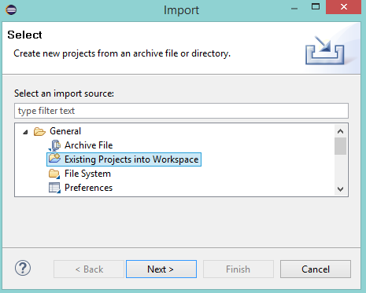

1. Select Next. Choose Browse. Scroll down to workspace and select your robot folder. Hit Ok.

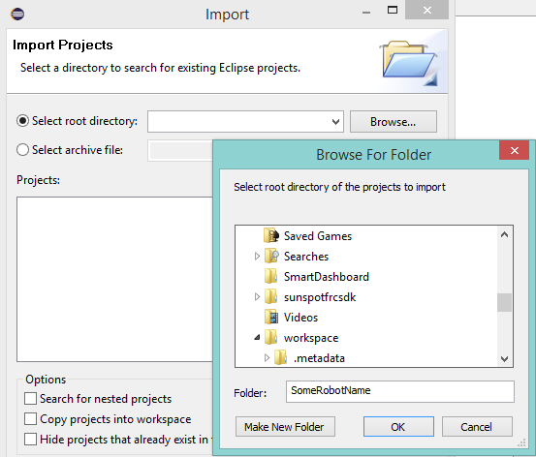

1. Make sure that the check mark next to your robot is selected. Hit Finish.

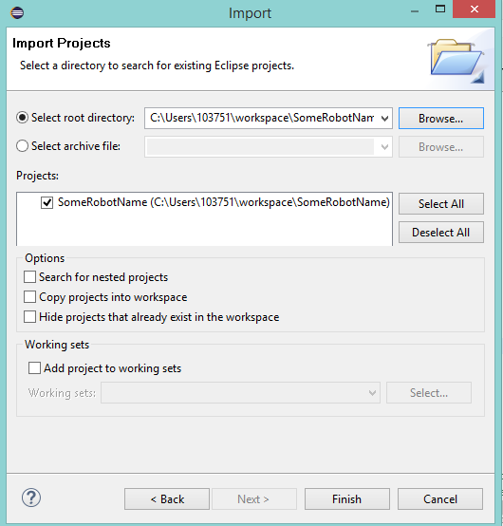

1. After a few moments, your robot project should open. Enjoy!